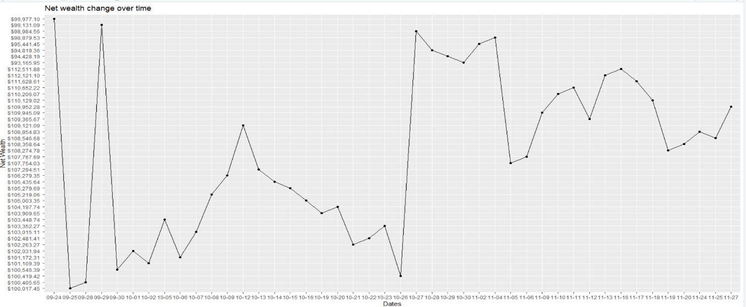In the VSE simulation exercise, I am given $100,000 to trade from to. At the end of Nov 27, 2020, my overall gain is $9952.28 with overall returns 9.95%. I have $0 cash remaining. My rank is #10 in my class. Among others, 1121 shares of XLV provides the most value with gain $6801.59. 90 shares of XLRE provides the lest values with gain $116.79.

On Sep 28rd, 2020, I use a daily return sample of XLK from Sep 28, 2020 to Oct 8, 2020 to perform analysis. In fact, I bought 290 of XLK at the market opening price $112.10 at 12:00pm on Sep 24th, 2020. Then I bought 209 of XLK at the marketing opening price $115.78 at 11:20am on Sep 28th . The rest of my wealth is $2600 in cash. My analysis is based on my knowledge of “capital allocation to risky assets”. First, I download the data and compute the excess return. Then, I assume that I have a risk aversion A=1.6. Next, I compute the risk premium and standard deviation of excess return. Finally, I compute my portfolio weight for XLK which is 0.27. The current price of XLK on Sep 24rd, 2020 is $112.10. This means I will propose to sell 200 of XLK at the market opening price on Sep 28th, 2020. The rest of my wealth is cash. My R code for this analysis is from line 10 to line 89 in “VSE_Yafei.R”. In fact, I sold 209 of XLK of $121.62 at the market opening price on. And the cash amount $25418 in cash

On Oct 8th, 2020, I use a daily return sample of SPY from Sep 28, 2020 to OCT 8, 2020 to perform analysis. In fact, I bought 3 of SPY at the market opening price $333.71 at 11:20pm on Sep 24th, 2020. Then I bought 32 of SPY at the marketing opening price $342.94 at 1:27pm on Oct 8th . The rest of my wealth is $7880.17 in cash. My analysis is based on my knowledge of “single index model”. First, I download the data and compute the excess return, Then, I assume that I have a risk aversion A=1.6. Next, I compute the risk premium and standard deviation of the SPY excess return. Finally, I compute my portfolio weight for SPY which is 0.74. The current price of SPY on Aug 3rd, 2020 is $328.79. This means I will propose to buy 55 of SPY at the market opening price on Oct 9th, 2020. The rest of my wealth is cash. My R code for this analysis is from line 50 to line 70 in “VSE_Yafei.R”. In fact, I bought 5 shares of SPY at the market opening price on. And is in cash $3078.87.

On Oct 25th, 2020, I use a daily return sample of XLRE from Sep 26, 2020 to Nov 25, 2020 to perform analysis. In fact, I bought 1508 of XLRE at the market opening price $35.11 at 2:14 pm on Sep 28th, 2020. Then I bought 617of XLRE at the marketing opening price $115.87 at 9:13am on Oct 3rd,2020. The rest of my wealth is $568.17 in cash. My analysis is based on my knowledge of “capital allocation to risky assets”. First, I download the data and compute the excess return. Then, I assume that I have a risk aversion A=1.6. Next, I compute the risk premium and standard deviation of the SPY excess return. Finally, I compute my portfolio weight for XLRE which is 0.89. The current price of XLRE on Oct 3rd, 2020 is $36.53. This means I will propose to sell 200 of XLRE at the market opening price on Nov 2th, 2020. The rest of my wealth is cash. My R code for this analysis is from line 10 to line 50 in “VSE_Yafei.R”. In fact, I sold 2035 share of XLRE at the market opening price on 2:53pm. And is in cash $70777.48.

On Nov 2rd, 2020, I use a daily return sample of XLV from Sep 24, 2020 to Nov 2nd, 2020to perform analysis. In fact, I bought 440 of XLV at the market opening price $103.24 at 2:50pm on Sep 24th, 2020. Then I bought 479 of XLV at the marketing opening price $103.22 at 10:13am on Nov 2nd. The rest of my wealth is $29070.17 in cash. My analysis is based on my knowledge of “single index model”. First, I download the data and compute the excess return. Then, I assume that I have a risk aversion A=1.6. Next, I compute the risk premium and standard deviation of the XLV excess return. Finally, I compute my portfolio weight for XLV which is 0.32. The current price of XLV on Nov 2nd, 2020 is $105.27. This means I will propose to buy 50 of XLV at the market opening price on Nov 2nd, 2020. The rest of my wealth is cash. My R code for this analysis is from line 10 to line 50 in “VSE_Yafei.R”. In fact, I bought 440 shares of XLV of at the market opening price on 10pm. And is in cash $1780.78.

On Nov 3rd, 2020, I use a daily return sample of XLK from Sep 24, 2020 to Nov 3, 2020 to perform analysis. In fact, I bought 28 of XLK at the market opening price $112.78 at 2:00pm The rest of my wealth is $1280.17 in cash. My analysis is based on my knowledge of “capital allocation to risky assets”. First, I download the data and compute the excess return. Then, I assume that I have a risk aversion A=1.6. Next, I compute the risk premium and standard deviation of the XLK excess return. Finally, I compute my portfolio weight for XLK which is 0.45. The current price of XLK on Aug 3rd, 2020 is $328.79. This means I will propose to buy 60 of XLK at the market opening price on Nov 4th, 2020. The rest of my wealth is cash. My R code for this analysis is from line 10 to line 50 in “VSE_Yafei.R”. In fact, I bought 10 shares XLK of at the market opening price on 11pm. And is in cash $0.

On Sep 29rd, 2020, I use a daily return sample of XLI from Sep 28, 2020 to Sep 29, 2020 to perform analysis. In fact, I bought 115 of XLI at the market opening price $112.10 at 12:00pm on Sep 24th, 2020. Then I bought 209 of XLI at the marketing opening price $115.87 at 9:13am on Sep 28th . The rest of my wealth is $267.67 in cash. My analysis is based on my knowledge of “single index model”. First, I download the data and compute the excess return. Then, I assume that I have a risk aversion A=1.6. Next, I compute the risk premium and standard deviation of the XLI excess return. Finally, I compute my portfolio weight for XLI which is 1. The current price of XLI on Sep 28th 2020 is $328.79. This means I will propose to buy 10 of XLI at the market opening price on Aug 4th, 2020. The rest of my wealth is cash. My R code for this analysis is from line 10 to line 50 in “VSE_Yafei.R”. In fact, I bought $0 of at the market opening price on. And is in cash $2089.78.

On Oct 12rd, 2020, I use a daily return sample of XLP from Sep 24, 2020 to Oct 12, 2020 to perform analysis. In fact, I bought 15 of XLP at the market opening price $112.10 at 12:00pm on Sep 24th, 2020. The rest of my wealth is $97890.97 in cash. My analysis is based on my knowledge of “capital allocation to risky assets”. First, I download the data and compute the excess return. Then, I assume that I have a risk aversion A=1.6. Next, I compute the risk premium and standard deviation of the XLP excess return. Finally, I compute my portfolio weight for XLP which is 0.04. The current price of XLP on Oct 12th, 2020 is $66.41. This means I will propose to sell 15 of XLP at the market opening price on Oct 12th, 2020. The rest of my wealth is cash. My R code for this analysis is from line 10 to line 50 in “VSE_Yafei.R”. In fact, I sold 15 shares of at the market opening price on. And is in cash $9250.62